Ime in priimek učenca:_________________________ Datum:_________________

- Prepiši spodnje povedi s pisanimi črkami. Pazi na pravopisna pravila.

ZAKAJ SMO ŠLI V SOBOTO V RADOVLJICO? OBISKALI SMO BABICO GRETO. ŽIVI V NIZKEM BLOKU. S SEBOJ SMO VZELI TUDI PSIČKO LUNO. Z BRATOM DEJANOM GREVA RADA NA BAZEN. RAD BI BIL NAJBOLJŠI PLAVALEC V SLOVENIJI. MOJ VZORNIK JE PETER MANKOČ. BRAVO, PETER!
____________________________________________________________________________________________________________________________________________________________________________________________________________________________________________________________________________________________________________

____________________________________________________________________________________________________________________________________________________________________________________________________________________________________________________________________________________________________________

____________________________________________________________________________________________________________________________________________________________________________________________________________________________________________________________________________________________________________

____________________________________________________________________________________________________________________________________________________________________________________________________________________________________________________________________________________________________________

____________________________________________________________________________________________________________________________________________________________________________________________________________________________________________________________________________________________________________

____________________________________________________________________________________________________________________________________________________________________________________________________________________________________________________________________________________________________________

____________________________________________________________________________________________________________________________________________________________________________________________________________________________________________________________________________________________________________

____________________________________________________________________________________________________________________________________________________________________________________________________________________________________________________________________________________________________________

____________________________________________________________________________________________________________________________________________________________________________________________________________________________________________________________________________________________________________

____________________________________________________________________________________________________________________________________________________________________________________________________________________________________________________________________________________________________________

- Napiši malo in veliko pisano abecedo:
____________________________________________________________________________________________________________________________________________________________________________________________________________________________________________________________________________________________________________

____________________________________________________________________________________________________________________________________________________________________________________________________________________________________________________________________________________________________________

____________________________________________________________________________________________________________________________________________________________________________________________________________________________________________________________________________________________________________

____________________________________________________________________________________________________________________________________________________________________________________________________________________________________________________________________________________________________________

____________________________________________________________________________________________________________________________________________________________________________________________________________________________________________________________________________________________________________

DODATNA NALOGA
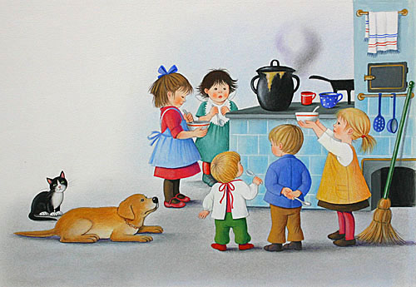
Opiši sliko.

_______________________________________________________________________________________________________________________________________________________________________________________________________________________________________________________________________________________________________________________
________________________________________________________________________________________________________________________________________________________________________________________________________________________________________________________________________________________________________________________
________________________________________________________________________________________________________________________________________________________________________________________________________________________________________________________________________________________________________________________
________________________________________________________________________________________________________________________________________________________________________________________________________________________________________________________________________________________________________________________
________________________________________________________________________________________________________________________________________________________________________________________________________________________________________________________________________________________________________________________

